Scoring Impact of Kicking or Receiving Each Half’s Opening Kickoff

Ryan Bach, Tanner Luce, Nick Nolkemper, Will Swanson

EXECUTIVE SUMMARY:

We recommend always electing to receive the opening kickoff as K-State scores nearly 25% more frequently on K-State's first drive of the game. They also have an average of 3.42 points scored, which is 75% higher than all other situations, and an average ending distance of 23.2 yards to goal, nearly 20 yards closer than all other situations.

**OBJECTIVE:**

Determine how either receiving or deferring the opening kickoff affects the success of Kansas State’s opening drive in each half using data from the 2019-2021 seasons.

**DATA:**

We collected data from the 31 games played, which can be classified by the result of the coin flip. Conference games are bolded:

Table 1: Games Analyzed

|  |  |  |
| --- | --- | --- |
| **Year** | **Receive 1st half / Kick 2nd half** | **Kick 1st half / Receive 2nd half** |
| 2019 | Nicholls  Bowling Green  **Texas**  **Iowa St.** | Mississippi St.  **Oklahoma St.**  **Baylor**  **TCU**  **Oklahoma**  **Kansas**  **West Virginia**  **Texas Tech** |
| 2020 | **Texas Tech**  **West Virginia**  **Baylor**  **Texas** | Arkansas St.  **Oklahoma**  **TCU**  **Kansas**  **Oklahoma St.**  **Iowa St.** |
| 2021 | Southern Illinois Nevada **Oklahoma St.** **Oklahoma** | Stanford **Iowa St.** **Texas Tech** **TCU**  **West Virginia**  **Baylor**  **Texas** |

**FINDINGS:**

After analyzing the data, the following table was created to display the aggregate findings:

Table 2: Aggregate Data Results

|  |  |  |  |  |
| --- | --- | --- | --- | --- |
|  | **Receive 1st half / Kick 2nd half** | | **Kick 1st half / Receive 2nd half** | |
| **Q1** | **Q3** | **Q1** | **Q3** |
| **Number of Games** | 12 | | 20 | |
| **Scoring %** | 58% | 33% | 35% | 40% |
| **Points For** | 41 | 20 | 45 | 48 |
| **Avg. Points Scored** | 3.42 | 1.67 | 2.25 | 2.40 |
| **Avg. Ending Distance** | 22.5 | 47.3 | 38.0 | 46.2 |

Some points of interest in the table are Q1-Receive has the highest scoring percentage, ties the highest points-for value even though they have 6 less games played, and also has the lowest average ending distance to goal.

Average Points Scored

Comparing the two outcomes of the coin toss, receiving in the first half and kicking in the second half has a better bottom line. In games where Kansas State received the opening kickoff, they scored 58% of the time for a total of 41 points, whereas when they kicked to open the game, they only scored 35% of the time on their opening drive for a total of 45 points. Even though receiving the opening kickoff occurred 6 less times than deferring, the total amount of points scored is nearly the same. The primary thing to highlight here is that the scoring percentage sees little deviation from the 30% to 40% range except for one situation: receiving to begin the game.

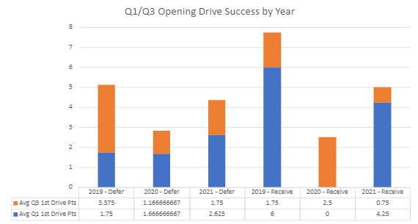

Figure 1: Q1/Q3 Avg Points Scored by Year and Defer/Receive

One interesting thing about this graph is in a non-COVID year (2019, 2021) receiving the opening kickoff is always better overall. While the sample size is very small, 2020 could be an outlier in the lack of production overall and also for Q1. Combining COVID and how then true freshman Will Howard stepped in for an injured Skylar Thompson, this seems more likely than not. Again, a small sample size makes this difficult to tell.

Average Ending Distance

Let’s say Kansas State had a great drive, but for whatever reason could not finish the drive even though they did drive down the field. Defining drive success this way, we can compare the average ending distance, measured by yards to the opponent’s endzone.

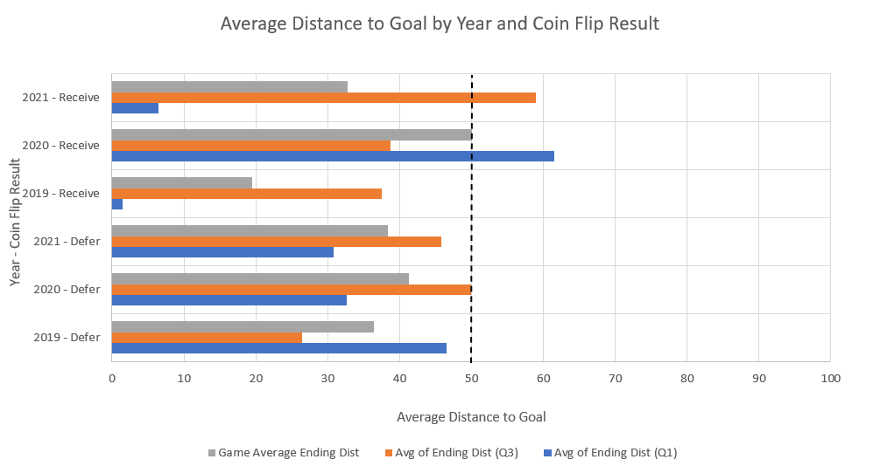

Figure 2: Average Distance to Goal by Year and Coin Flip Result

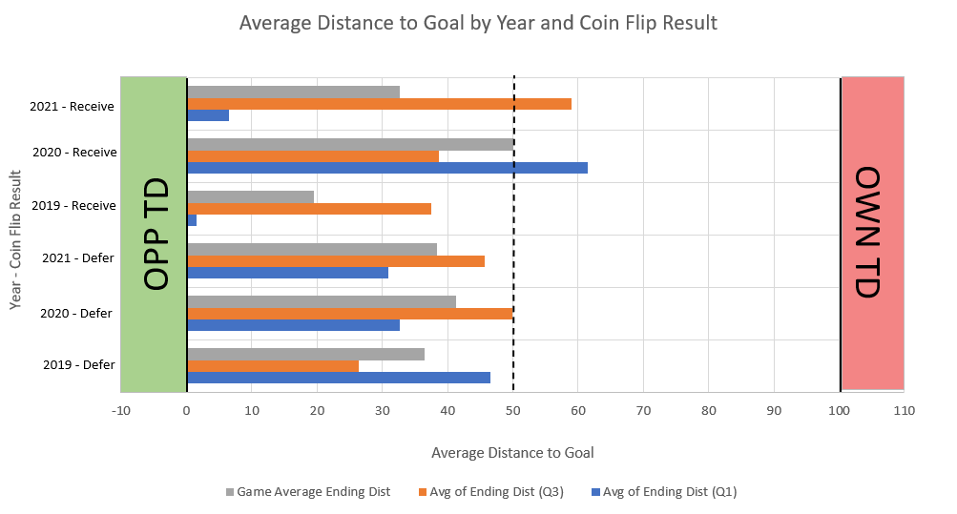

Figure 3: Average Distance to Goal by Year and Coin Flip Result (Field View)

When Kansas State receives the first half kickoff, they have an average ending distance of 22.5 yards and 47.3 yards in the first and third quarters, respectively. This can be compared to if Kansas State was to kick to start the game and receive the second half kickoff in which they average ending at 38.0 yards and 46.2 yards away in quarters 1 and 3, respectively. Again, Kansas State does abnormally well in the opening drive of the game when receiving comparatively to all other situations. Even if Kansas State does not score a touchdown on any given drive, the ending distance for receiving the opening kickoff creates on average about a 40-yard field goal, while the other situations force K-State to punt the ball.

**RECOMMENDATION**

Since there is no large variance between 3rd quarter drives in both a deferring and receiving case as well as a 1st quarter in a defer case, the main thing to look at is the outlier: 1st quarter opening drive success when receiving the kickoff. It has had sustained success and puts Kansas State in a position to win more football games. All that being said, **we recommend that if Kansas State wins the toss, elect to receive the first-half kickoff.**

**FUTURE WORK**

Our senior design team’s primary objective is to identify potential root causes for Kansas State’s 3rd quarter offensive struggles using a data-driven approach. In improving that, this would emphasize the upside of receiving the opening kickoff since the first quarter would be of primary concern in that case. Overall, this is something that needs to be continually monitored to identify different trends in the data.